Measurement of 5-Overtone Quality Factor of QCM Sensor with Asymmetric Ring Electrodes
Jianguo Hu¹, Yuxuan Gong¹, Yangbin Wei¹, Guangkun Luo¹, Zhigang Wang¹, Hao Li^{1*}, and Tian-Ling Ren^{2*}
The quartz crystal microbalance (QCM) sensor with asymmetric ring electrodes has received widespread attention for its uniform sensitivity distribution. At the same time, its 5-overtone mass sensitivity also greatly improves the fundamental frequency mass sensitivity. The 5-overtone quality (Q) factor is a technical indicator to measure the stable operation of the quartz crystal resonator with asymmetric ring electrodes in the fifth overtone mode. However, there are few papers to report the 5-overtone quality factor (Q₅) of QCM sensor with asymmetric ring electrodes. Therefore, it is a crucial value to measure the 5-ovetone Q factor of the QCM sensor with asymmetric ring electrodes. In addition, the actual 5-overtone quality parameter Q₅ is different to the nominal 5-overtone quality parameter Q’₅. The experimental results show that all the actual 5-overtone quality factor values are larger than 88400. Hence, these results strongly support the QCM sensor with asymmetric ring electrodes to operate stably in the fifth overtone mode. This research work will inspire new applications of QCM sensors with asymmetric ring electrodes in the fifth overtone mode.

Overview of QCM Sensor with Asymmetric Ring Electrodes
The quartz crystal microbalance (QCM) sensor with asymmetric ring electrodes has attracted the attention of a large number of researchers for its uniform sensitivity distribution [1-4], especially the QCM sensor with asymmetric ring electrodes [5]. Compared with the mass sensitivity in the fundamental frequency mode, its fifth overtone mass sensitivity has been greatly improved [6,7]. However, the stability of QCM sensor with asymmetric ring electrodes operating in the fifth overtone mode is unclear and requires further research. 5-overtone Q factor is closely relation with stability of QCM sensor with asymmetric ring electrodes operating in the fifth overtone mode.
QCM sensors have used widely in many areas due to German scientist Sauerbrey’s pioneering research in quartz crystal resonator, and he proposed the famous equation that describe the relationship between mass change and frequency change of the quartz crystal resonator [8-12]. This relationship is usually expressed by the following formula [8],
(1)
where ∆m is the mass change on the electrode surface; ∆f is the resonance frequency of the quartz crystal resonator caused by rigid mass loading; n is overtone number of QCM sensor (here n=5); f₀ is the nominal fundamental resonance frequency of QCM sensor (f₀=10 MHz); A is the active electrode area; μ_{q} (μ_{q}= 2.947×10¹¹ g/cm·s²) is the shear modulus of AT-cut quartz crystal; ρ_{q} (ρ_{q}=2.643 g/cm³) is the density of quartz crystal. Besides, the negative sign indicates that an increase in the rigid mass loading on the electrode surface will lead to a decrease in the resonance frequency.
Recently, the uniformity of mass sensitivity of QCM sensors and the new mechanism of sensitivity enhancement have become two important directions in QCM sensor research [13-17]. Specifically, the uniformity of mass sensitivity affects the reliability and repeatability of QCM sensor detection, and sensitivity determines the detection accuracy of the QCM sensor and is the core performance indicator of the sensor. For the uniformity of mass sensitivity of QCM sensors, many researchers have proposed new sensor electrode structures to improve the uniformity. Huang et al. presented a new asymmetric ring electrode of QCM sensor for improving the uniformity of mass sensitivity distribution [4]; Jiang et al. designed a double-ring electrode geometry of QCM sensor to improve the uniformity of mass sensitivity distribution [18]; Pan et al. proposed a dot multiring electrode structure of QCM sensors to solve the non-uniformity problem of mass sensitivity distribution [19]; A ring-dot electrode configuration to improve the mass sensitivity distribution was developed by Emadi [20]. Similarly, many researchers have done excellent work on the sensitizing mechanism and sensitizing methods of QCM sensors [21]. Chen et al. proposed an ultrasensitive QCM humidity sensor using graphene oxide and hydroxylated graphene quantum dots as the sensitive materials [22]; Ogi et al. developed a wire-less-electrodeless approach to achieve high sensitivity through thinner quartz crystal resonators [23]; A PMMA micropillar-based QCM sensor to enhance the sensitivity was pro-posed by Nastaran Tehrani [24]; A new overtone sensitization mechanism has been proposed, which greatly improves sensitivity [7]. Therefore, combining the overtone enhancement mechanism and the advantages of asymmetric ring electrode QCM sensors, the asymmetric ring electrode QCM sensors operating in the fifth overtone resonant mode deserve further research.
In this work, we study detailly the actual 5-overtone quality (Q₅) factor and the nominal 5-overtone quality (Q’₅) factor of QCM sensor with asymmetric ring electrodes. Firstly, we designed the QCM sensors with asymmetric ring electrodes. Secondly, we analyzed the differences between the actual 5-overtone quality parameter Q₅ and the nominal 5-overtone quality parameter Q’₅ of QCM sensors with asymmetric ring electrodes operating in 5-overtone mode. Finally, the measurement system for obtaining the actual 5-overtone quality factor was built. The experimental results show that all the actual 5-overtone quality factor values are larger than 88400. These results strongly prove that the QCM sensors with asymmetric ring electrodes can operate stably in the fifth overtone mode.

Theory and Method
The QCM sensor with asymmetric ring electrodes is shown as Fig.1, and its core part is AT-cut 10 MHz quartz crystal resonator with asymmetric ring electrodes (Wuhan Hitrusty Electronics Co., Ltd. Wuhan, Hubei province, China). In short, the QCM sensor with asymmetric ring electrodes is composed of a ring electrode (up electrode) and a disc electrode (bottom electrode) evaporated on the upper and lower surfaces of a quartz crystal wafer. The diameter of the quartz crystal wafer (d₁) is 8.7 mm, and the diameter of the disc electrode is 5.1 mm. d₂(d₂=5.1 mm), d₃(d₃=2 mm) are the outer and inner diameters of the ring electrode. A₁, A₂, and A₃ is non-electrode areas, full electrode areas and partial electrode areas, respectively. Specifically, non-electrode areas, full electrode areas and partial electrode areas mean quartz wafer areas without electrode layer on both sides, with an electrode layer on both sides, and an electrode layer on bottom side only, respectively. The thicknesses of the ring electrode and the disc electrode are both 800 Å, and the thickness of the quartz crystal wafer is 0.167mm. Additionally, W₁ (W₁=0.3mm) is the width of an opening in the ring structure, it should be noted that the reason for this opening is due to manufacturing restrictions.
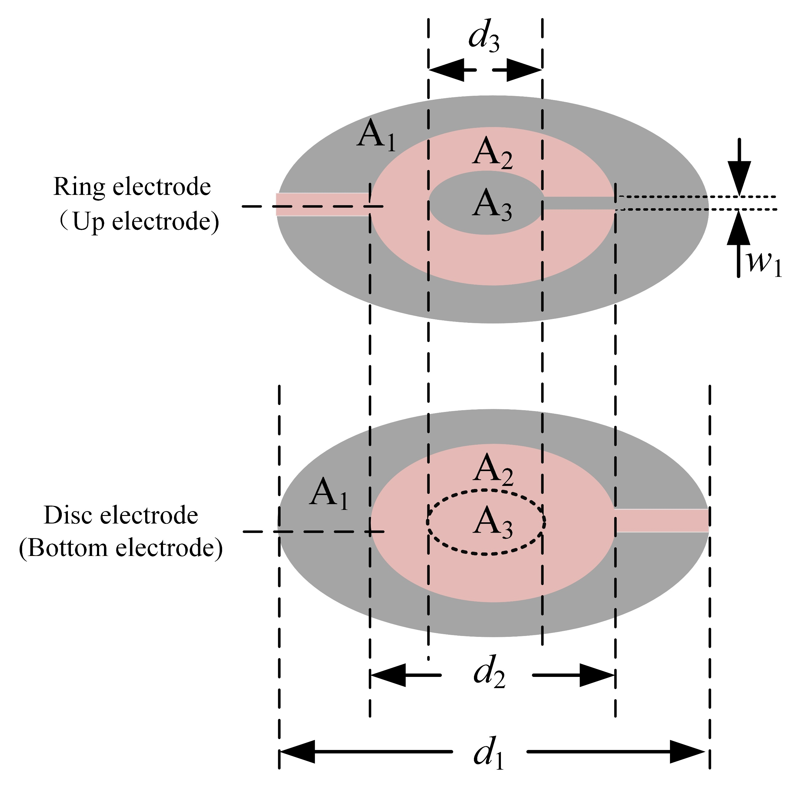
Fig. 1. Structure diagram of the QCM sensor with asymmetric ring electrodes.

According to the Sauerbrey equation, we can know that the improvement of mass sensitivity of the QCM sensor with asymmetric ring electrodes can be achieved by increasing resonance frequency of the quartz crystal resonator with asymmetric ring electrodes. However, increasing the resonance frequency requires reducing the thickness of the quartz crystal wafer. Thin quartz crystal wafers are prone to damage due to the fragility of the quartz crystal wafer itself, resulting in extremely low yield rates for asymmetric ring quartz crystal resonator with high resonance frequencies, which are not suitable for large-scale production. The 5-overtone resonance frequency of the quartz crystal resonator with asymmetric ring electrodes is 5 times that of its fundamental frequency. Obviously, in theory, the 5-overtone mass sensitivity of the QCM sensor with asymmetric ring electrodes is five times that of its fundamental mass sensitivity. However, the stability of the QCM sensor with asymmetric ring electrodes operating in the fifth overtone mode is a prerequisite for its application.
The Q factor characterizes the stability of QCM sensor with asymmetric ring electrodes. Similarly, the 5-overtone Q factor also presents the stability of QCM sensor with asymmetric ring electrodes operating in 5-overtone mode. It is well known that the Q fac-tor can be used to quantify the resonance frequency sharpness of quartz crystal resonator [25]. In addition, Q factor also can present the ability of a QCM sensor with asymmetric ring electrodes to detect minimum frequency changes [26]. The Q factor can be calculated by the fellow equation [27],
(2)
where f₀ is the nominal fundamental resonance frequency; 2г is half-bandwidth. This equation shows that the Q factor is decided by the resonance frequency and half-bandwidth.
Similar to the definition of the fundamental Q factor, the 5-overtone Q factor (Q₅) of QCM sensor with asymmetric ring electrodes can be described as follow,
(3)
where f_{R5} is the 5-overtone resonance frequency; 2г₅ is the half-bandwidth under 5-overtone mode.
Schematic diagrams of resonance frequency and conductance of the QCM sensor with asymmetric ring electrodes operating in fundamental mode and 5-overtone mode are shown as Fig.2. 2г_{r} and 2г_{5r} are the half-bandwidths of QCM sensor with asymmetric ring electrodes in fundamental mode and 5-overtone mode, respectively. Due to limitations such as manufacturing process, the actual resonance frequency of an asymmetric ring electrode QCM sensor with a nominal resonance frequency of 10MHz is not strictly equal to 10MHz. However, the nominal fundamental resonance frequency f₀ is usually used as the actual fundamental resonance frequency f_{r}, which can lead to errors in application. 2г₀ and 2г₅ are the nominal half-bandwidth and the nominal half-bandwidth of QCM sensor with asymmetric ring electrodes in fundamental mode and 5-overtone mode, respectively. In addition, the actual 5-overtone resonance frequency f_{5r} is also not strictly equal to five times that of actual fundamental resonance frequency f_{r}. According to the equation (3), the Q₅ is determined by the actual 5-overtone resonance frequency f_{5r} and 2г_{5r}. Hence, if 5f₀ is used instead of the actual 5-overtone resonance frequency f_{5r} when calculating the 5-overtone quality factor, then the errors will be caused.
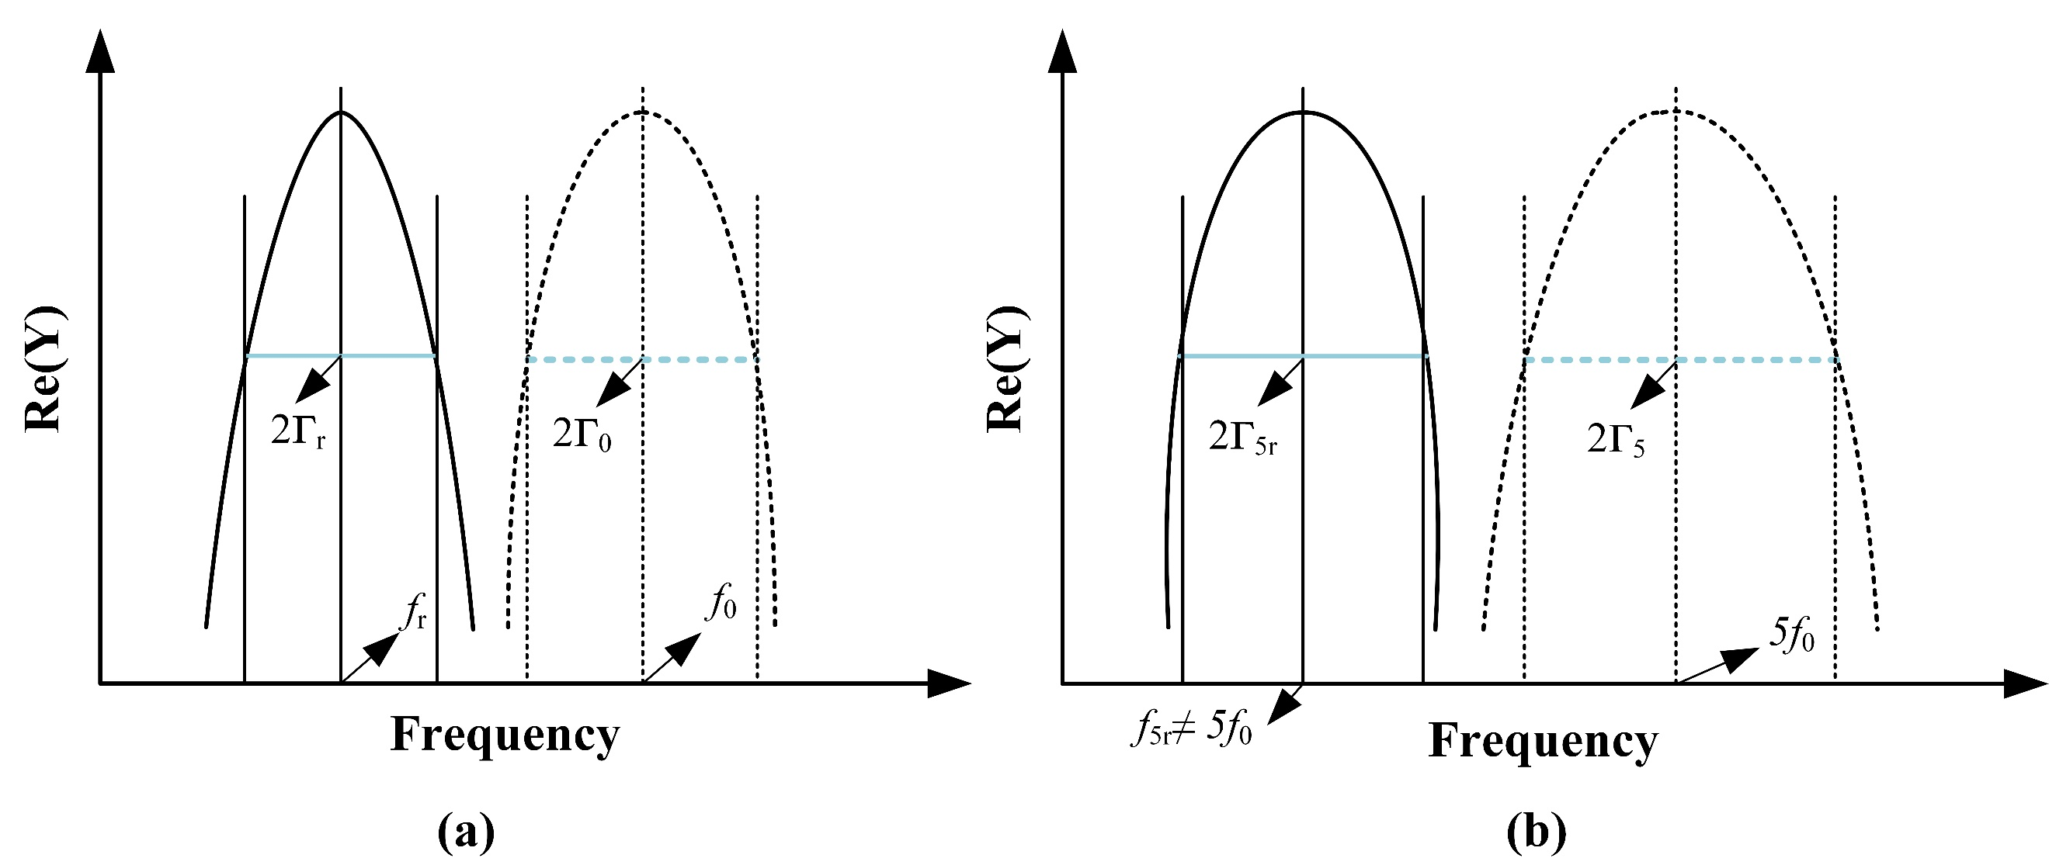
Fig. 2. Schematic diagram of frequency and conductance of the QCM sensor with asymmetric ring electrode operating in fundamental mode and 5-overtone mode. The dot line is the conductance diagram of the nominal resonance frequency, and the real line diagram is the actual resonance frequency. (a) Fundamental mode; (b) 5-overtone mode.

According to the equation (3), the 5-overtone Q factor (Q₅) is determined by the actual 5-overtone resonance frequency and half-bandwidth of the QCM sensor with asymmetric ring electrodes operating in 5-overtone mode. On the other hand, we also considered that the actual 5-overtone resonance frequency is different with the nominal 5-overtone resonance frequency. Therefore, in order to obtain the actual 5-overtone resonance frequency of QCM sensor with asymmetric ring electrodes, we constructed an experimental measurement system. Fig. 3 shows that the experimental measurement system is constructed to measure the actual 5-overtone resonance frequency of QCM sensor with asymmetric ring electrodes. QCM sensor with asymmetric ring electrodes is placed in the measuring cell we designed, and the cell is connected to the temperature controller. Temperature adjustment of experimental measurement system is controlled by the temperature controller Julabo 4 (Julabo GmbH, Germany), and the experimental system operates at room temperature to restrain the influence of ambient temperature change on measurement. Finally, we used the network analyzer Agilent E5100A (Agilent technologies, US) to measure the actual 5-overtone resonance frequency and half-bandwidth of QCM sensor with asymmetric ring electrodes. Then, we can calculate the actual 5-overtone Q factor by the equation (3).
Fig. 3. Measurement system schematic diagram of the actual 5-overtone resonance frequency and half-bandwidth of QCM sensor with asymmetric ring electrodes.

Experimental Results
The actual 5-overtone quality factor Q₅ was calculated by the equation (3), and the calculation results were shown as in Table II. 2г_{5r} is the actual half-bandwidth of QCM sensor with asymmetric ring electrodes operating in fifth overtone mode. All the actual 5-overtone quality factor values are larger than 88400, and these results show that the QCM sensors with asymmetric ring electrodes can operate stably in the fifth overtone resonant mode. That is to say, the applications and measurements of the QCM sensor with asymmetric ring electrodes operating in 5-overtone mode are reliable.
Table 1. 5-Overtone Quality Factor of QCM with Asymmetric Ring Electrodes.

Conclusion
In this paper, we studied the 5-overtone quality factor of the QCM sensor with asymmetric ring electrodes. The 5-overtone quality factor is an important parameter of QCM sensor with asymmetric ring electrodes operating in 5-overtone mode, which is closely related to the related changes in the detection process. In fact, we need to distinguish that there is a difference between the actual 5-overtone quality factor and the nominal 5-overtone quality factor. The experimental results show that the actual 5-overtone quality parameter Q₅ are 133318, 91182, 88401 and 97307, and these high Q₅ values strongly demonstrate the excellent stability of the QCM sensors with asymmetric ring electrodes operates in the fifth overtone mode. This research work will inspire new applications of QCM sensors with asymmetric ring electrodes in the fifth overtone mode and also promote their application in sensing and detection fields.

Acknowledgment
This work was supported by the National Natural Science Foundation of China (62301297).

References
- F. Josse, Y. Lee, S. J. Martin, and R. W. Cernosek, “Analysis of the radial dependence of mass sensitivity for modified-electrode quartz crystal resonators,” Anal. Chem., vol. 70, pp. 237-247, 1998, DOI:10.1021/ac9706032.
- P. Y. Wang, M. X. Ling, and M. H. Li, “Design and Analysis of Quartz Crystal Microbalance with a New Ring-Shaped Interdigital Electrode,” Sensors, vol. 22, issu. 19, 7422, 2022, DOI10.3390/s22197422.
- A. Richardson, V. R. Bhethanabotla, A. L. Smith, and F. Josse, “Patterned electrodes for thickness shear mode quartz resonators to achieve uniform mass sensitivity distribution,” IEEE Sens. J., vol. 9, pp. 1772-1777, 2009, DOI:10.1109/ICSENS.2008.4716659.
- X. Huang, Q. Bai, W. Pan, and J. Hu, “Quartz crystal microbalance with approximately uniform sensitivity distribution,” Anal. Chem., vol. 90, pp. 6367-6370, 2018, DOI: 10.1021/acs.analchem.8b01529.
- F. Zhu, B. Wang, X. Y. Dai, Z. H. Qian, I. Kuznetsova, V. Kolesov, and B. Huang, “Vibration optimization of an infinite circular AT-cut quartz resonator with ring electrodes,” App. Mat. M., vol. 72, pp. 217-229, 2019, DOI: 10.1016/j.apm.2019.03.014.
- H. F. Jiang, and L. F. Tang, “Uniform Mass Sensitivity Distribution of Elliptically Designed Electrodes Based on a Quartz Crystal Microbalance,” ACS Omega, vol. 6, issu. 48, pp. 32917-32924, 2021, DOI10.1021/acsomega.2c02771.
- J. G. Hu, G. Yesilbas, Y. Y. Li, X. S. Geng, P. Li, J. Chen, X. M. Wu, A. Knoll, and T. L. Ren, “Exploration of the Mass Sensitivity of Quartz Crystal Microbalance under Overtone Modes Using Electrodeposition Method,” Anal. Chem., vol. 94, pp.5760-5768, 2022, DOI10.1021/acs.analchem.1c04648.
- G. Sauerbrey, “Verwendung von Schwingquarzen zur Wägung dünner Schichten und zur Mikrowägung,” Z. Phys., vol. 155, pp. 206-222, 1959, DOI:10.1007/BF01337937.
- F. Fika, R. Aditya, S. Iman, and T. Kuwat, “Gas and humidity sensing with quartz crystal microbalance (QCM) coated with graphene-based materials-A mini review,” Sens. Actua. A-Phys., vol.330, 112837, 2021, DOI10.1016/j.sna.2021.112837.
- J. P. Singh, A. Sharma, M. Verma, M. Tomar, and A. Chowdhuri, “Mechanism of trace-level detection of dibutyl sulfide (DBS) at room temperature using UV-activated MoO3 coated quartz crystal microbalance (QCM) sensor,” Sens. Actuat. B-Chem., vol. 426, 137102, 2025, DOI10.1016/j.snb.2024.137102.
- S. Takeda, W. Tanaka, T. Hosomi, T. Takahashi, J. Y. Liu, and T. Yanagida, “On-Site Nanowire Growth of Peptides Enables Stable Amine Selective QCM Gas Sensing,” Nano Lett., 2025, DOI10.1021/acs.nanolett.4c05183.
- M. A. Teixeira, N. S. Murthy, D. P. Ferreira, and H. P. Felgueiras, “Assessment of Linear and Cyclic Peptides' Immobilization onto Cross-Linked, Poly (vinyl alcohol)/Cellulose Nanocrystal Nanofibers Electrospun over Quartz Crystal Microbalances with Dissipation Sensors,” Langmuir, vol. 40, issu. 50, pp. 26425-36435, 2024,
- J. G. Hu, and X. H. Huang, “QCM Mass Sensitivity Analysis Based on Finite Element Method,” IEEE Trans. Appl. S., vol. 29, issu. 2, 9000504, 2019,
- A. Abu-Libdeh, Y. E. Elnemr, G. C. A. Raj, B. S. Ye, M. Rinzan, and A. Emadi, “QCM Electrode Configurations for Enhanced Mass Distribution and Sensitivity,” IEEE Sens. J., vol. 24, issu. 23, pp. 38843-38850, 2024,
- M. D. Ward, and E. J. Delawski, “Radial Mass Sensitivity of the Quartz Crystal Microbalance in Liquid-Media,” Anal. Chem., vol. 63, issu. 9, pp. 886-890, 1991, DOI10.1021/ac00009a009.
- S. N. Songkhla, and T. Nakamoto, “Overview of Quartz Crystal Microbalance Behavior Analysis and Measurement,” Chemosensors, vol. 9, issu. 12, 350, 2021, DOI10.3390/chemosensors9120350.
- E. Zampetti, M. A. Mancuso, F. Dirri, E. Palomba, P. Papa, A. Capocecera, A. Bearzotti, A. Macagnano, and D. Scaccabarozzi, “Effects of Oscillation Amplitude Variations on QCM Response to Microspheres of Different Sizes,” Sensors, vol. 23, issu. 12, 5682, 2023, DOI10.3390/s23125682.
- H. F. Jiang, and L. F. Tang, “Uniformization of QCM’s Mass Sensitivity Distribution by Optimizing Its Metal Electrode Configurations,” IEEE Sens. J., vol. 21, no. 7, pp. 9008-9015, 2021, DOI10.1109/JSEN.2021.3056108.
- W. Pan, X. H. Huang, and Q. Chen, “Analysis of the Uniformization of the QCM Mass Sensitivity Distribution through a Dot Multiring Electrode Structure,” Anal. Chem., vol. 93, pp.16828-16834, 2021, DOI10.1021/acs.analchem.1c03443.
- S. Swaminathan, and A. Emadi, “Design and Analysis of a Novel Quartz Crystal Microbalance Utilizing Distributed Mass Loading Area for Improved Sensitivity,” IEEE Sens. J., vol.23, no.6, pp.5643-5649, 2023, DOI10.1109/JSEN.2023.3242172.
- Y. Yao, H. Zhang, and X. H. Huang, “Enhanced sensitivity of quartz crystal proximity sensors using an asymmetrical electrodes configuration,” Sens. Actua. A-Phys., vol.258, pp.95-100, 2017, DOI10.1016/j.sna.2017.03.001.
- X. Ding, J. Li, W. Hu, X. D. Chen, and W. H. Xia, “An Ultrasensitive QCM Humidity Sensor Based on GO/OH-GQDs,” IEEE Sens. J., vol.24, no.17, pp.27191-27197, 2024, DOI10.1109/JSEN.2024.3432606.
- H. Ogi, “Ultrasensitive wireless quartz crystal microbalance bio/gas sensors,” J. J. Appl. Phys., vol.63, 040802, 2024, DOI10.35848/1347-4065/ad308e.
- N. A. Tehrani, I. C. Esfahani, and H. W. Sun, “Simultaneous humidity and temperature measurement with micropillar enhanced QCM sensors,” Sens. Actua. A-Phys., vol.366, 114039, 2024. DOI10.1016/j.sna.2024.115039.
- I. R. Jang, J. Park, C. Ryu, S. I. Jung. H. N. Kim, S. B. Kim, and H. J. Kim, “High Precision Liquid Salinity Sensing Using a CNT Coated Quartz Crystal Microbalance,” IEEE Sens. J., vol.22, no.8, pp.7684-7691, 2022, DOI10.1109/JSEN.2022.3157465.
- T. Kartanas, V. Ostanin, P. K. Challa, R. Daly, J. Charmet, and T. P. J. Knowles, “Enhanced quality factor label-free biosensing with micro-cantilevers integrated into microfluidic systems,” Anal. Chem., vol. 89, pp.11929-11936, 2017, DOI10.1021/acs.analchem.7b01174.
- D. Johannsmann, “The quartz crystal microbalance in soft matter research,” Springer, Switzerland, 2015.

Jianguo Hu (Member, IEEE) received the PhD Degree in automation from University of Electronic Science and Technology of China, Chengdu, in 2021. He finished his postdoctoral fellow at Tsinghua University in 2023, then he joined in Tianjin University as an associate professor at November 2023. Currently, he is an assistant professor at University of Electronic Science and Technology of China. His research interests include quartz crystal resonator, QCM sensors and biosensors and so on.
Yuxuan Gong is an undergraduate, and she is studying in high Q quartz crystal resonator under the guidance of assistant prof. Hu.
Yangbin Wei received his master degree from University of Electronic Science and Technology of China, Chengdu, in 2024. He is a Ph.D candidate at University of Electronic Science and Technology of China, and his research interests include ADC, signal processing and data analysis.
Guangkun Luo is an associate professor at University of Electronic Science and Technology of China. His research interests include signal processing and algorithm design.
Zhigang Wang is a professor at University of Electronic Science and Technology of China. His research interests include signal processing, spectrum analysis and instrument design.
Hao Li (haoli@uestc.edu.cn) received the PhD Degree in automation from University of Electronic Science and Technology of China, Chengdu, in 2020. He finished his postdoctoral fellow at University of Electronic Science and Technology of China in 2021, then he joined in University of Electronic Science and Technology of China as an assistant professor. His research interests include signal processing and communication system design.
Tian-Ling Ren (Fellow, IEEE) (rentl@tsinghua.edu.cn) received his Ph.D. degree in Department of Physics, Tsinghua University in 1997. He serves as a full Professor in Institute of Microelectronics, Tsinghua University (Now known as School of Integrated Circuit, Tsinghua University) since 2003. From 2011 to 2012 he was a visiting Professor in Department of Electrical Engineering, Stanford University, USA. He has long been committed to the research of novel intelligent micro-nano devices, chips, and systems, including intelligent sensors and integrated systems, 2D electronic devices and chips, flexible and wearable devices and systems. In recent years, he has achieved many important innovations in the field of novel 2D material electronic devices and various advanced devices and chips, such as transistors with the smallest physical gate length in the world, intelligent artificial throat, intelligent artificial eardrums, graphene 3D human-computer interfaces, novel non-volatile memory, graphene-based light-emitting devices with adjustable spectrum, and bionic synaptic devices. He has published more than 750 journal or conference papers, such as Nature, Nature Electronics, Nature Machine Intelligence, Nature Communications, Energy & Environmental Science, Advanced Materials and so on. He is also a co-inventor of more than 70 patents. His research has been supported by the National Natural Science Foundation of China, the Key R&D Program of the Ministry of Science and Technology, and the Beijing National Research Center for Information Science and Technology.

